AMERICAN HERDING BREED ASSOCIATION TRIALS
Sponsored by Melinda Stevenson (Latigo Farm)
TWO TRIALS/TWO DAYS
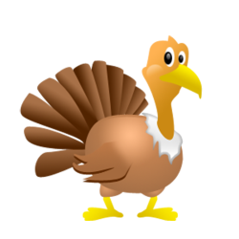
FALL TURKEY DAYS TRIAL

SATURDAY, NOVEMBER 17, 2018
SUNDAY, NOVEMBER 18, 2018

HERDING RANCH DOG (HRD I, II, III), SHEEP - Course map and description enclosed
HRD Course is pending AHBA approval
HERDING TRIAL ARENA DOG (HTAD I, II, III) SHEEP Course #2 with Gather/Ribbon Pull
HERDING TRIAL ARENA DOG (HTAD I, II, III) DUCKS Course #2 with Gather/Shed
HERDING TRIAL DOG (HTD I, II, III) DUCKS
JUNIOR HERDING DOG (JHD) DUCKS ONLY

LOCATION: 27560 EAST 77THS ST S., BROKEN ARROW, OK 74014

SATURDAY JUDGE: Dana Mackenzie (Breckenridge, TX)
SUNDAY JUDGE: Laura De La Cruz (New Mexico)

Pre Entry $40/Day of entry $45
Combined sheep runs limited to maximum 30 runs/day
Combined duck runs limited to maximum 25 runs/day
Trials Limited to a Total of 50 Runs/Day

Pre Entries close November 7th, 2018
THERE MUST BE A SEPARATE ENTRY FORM FOR EACH DOG, AND EACH TRIAL LEVEL ENTERED, Entry form is in this premium or you can find one on the AHBA website,
http://www.ahba-herding.org/
Pre Entries close November 7th, 2018, must be received by midnight
Day of entries accepted day of the event (thirty minutes prior to the class beginning)

HANDLER’S MEETING AT 8:00 A.M
JUDGING SCHEDULED TO BEGIN AT 8:15 A.M.

Event Hours: 8:00 am to 6:00 pm, or one hour after the conclusion of this event
Event will be held outside regardless of weather
Permission has been granted by the American Herding Breeds Association (AHBA)
to hold the Trial under the AHBA Rules and Regulations.
Open to all Dogs of the Herding Breeds and Multi-Purpose Breeds with Herding Background, as listed in the AHBA Breeds List (Dogs must be 9 months or older for trial)
Mail entries to the Trial Secretary:
Lynze Smith, 14105 Will Sampson Rd, Beggs, OK 74421
Cell Phone (918) 729-0150 or E-mail: lynzeforcows@gmail.com
More info and the Premium is also available on www.latigofarm.net

OFFICIAL AHBA ENTRY FORM
AHBA SANCTIONED HERDING TEST AND TRIAL
NAME OF CLUB or PERSON(S) Sponsoring this Event: Melinda Stevenson, Property owner at 27560 East 77th St. S., Broken Arrow OK 74014
Date of Event: November 17th and 18th, 2018
Pre Entries Close On: November 7, 2018
Pre entries must be received no later than Nov 7th at midnight.
Day of entries accepted till trial fills; Day of entry closes thirty minutes prior to class
Make checks or money orders payable in US funds to: Melinda Stevenson
Mail to the Trial Secretary : Lynze Smith, 14105 Will Sampson Rd, Beggs, OK 74421

ELIGIBILITY: All dogs nine months of age or older are eligible to participate in Herding Trials and JHD. Dogs classified as Herding Dogs in AHBA are eligible for HERDING TEST (HCT) and may participate at six months of age or older. No dog may be entered in two classes on the same course with the same kind of stock under the same judge at any Test/Trial. Bitches in season shall run in drawn running order without adjustment.
IMPORTANT. READ THIS BEFORE SIGNING RELEASE FORM
In consideration for participation in the Herding Test/Trial held by Melinda Stevenson, I (we) agree to assume all responsibility for any claim, loss or damage, of whatever kind or nature, whether to person or property, which may be caused at or near the Herding Test/Trial, either directly or indirectly, by me or the dog or dogs I (we) have entered or brought to this Herding Test/Trial. I (we) further agree that I (we) will hold Melinda Stevenson, AHBA, its Officers, Directors, Agents and Members; harmless and defend them from any and all liability for any injury, claim, damage or loss, of whatever kind, directly or indirectly, by me (us) or any dog I (we) have entered or brought to this Herding Test/Trial. I (we) agree to indemnify Melinda Stevenson, the AHBA, its Officers, Directors, Agents and Members; for any loss, cost, or expenses, including attorney fees and costs, in which Melinda Stevenson,the AHBA, its Officers, Directors, Agents and Members; might be subject to as a result of any claim, suit, loss or damage caused in any way by any act or negligence on my (our) part or on the part of any dog of dogs I (we) have entered or brought to the Herding Test/Trial. I(we) acknowledge that while Melinda Stevenson may provide for this Herding Test/Trial, it does not have and does not exercise control over the conduct of those present. I (we) certify and represent that the dog or dogs I (we) have entered or brought to this Herding Test/Trial is (are) not a hazard to other dogs, other animals, or to people. I (we) will pay for injuries or replacement value in the event of the death of any livestock by my (our) dog. If injury to any stock is caused by my (our) dog entered or brought to this Herding Test/Trial, I (we) assume full responsibility for any damage. I(we) agree to pay full market value of the injured animal in case of injury or the veterinary bill for the injury, whichever is agreed to by the Livestock Owner. I CERTIFY that I am the actual owner of the dog or that I am the duly authorized agent of the actual owners whose name I have entered.
In consideration of the acceptance of this entry, I (we) agree to abide by the Rules and Regulations of the AHBA in effect at the time of this Herding Test or Trial or both, and further agree to be bound by the agreement printed above. The entry is submitted on the foregoing representation and agreement.
Signature of Owner &/or Agent:

______________________________________________________________________________
Saturday, November 17, 2018
Sunday, November 18, 2018

Herding Ranch Dog (HRD) I, II, III – Sheep- Pre Entry $40/Day of entry $45
Herding Trial Arena Dog (HTAD) I, II, III- Sheep - Pre Entry $40/Day of entry $45
Herding Trial Arena Dog (HTAD) I, II, III - Ducks- Pre Entry $40/Day of entry $45
Herding Trial Dog (HTD) I, II, III - Ducks- Pre Entry $40/Day of entry $45
Junior Herding Dog (JHD) I, II, III - Ducks- Pre Entry $40/Day of entry $45
Entry form must be returned with the release form signed. Any entries received without the signed release will not be accepted.
NOTE: A dog must be entered in the name of the person(s) who actually owns it at the time entries are made for the Herding Test or Trial. A Registration or Tracking Number must be included. Tracking enrollment forms are available on location and will be included with trial results for those folks not yet registered with AHBA, your recorded scores may be delayed until a number is issued by AHBA.
Please circle appropriate class(s)
TRIALS | HRDs | I | II | III $40/$45
TRIALS | HTADs | I | II | III $40/$45
TRIALS | HTADd | I | II | III $40/$45
TRIALS | HTDd | I | II | III $40/$45
TEST | JHD | I | II | $40/$45
ONE FORM PER DAY PER DOG
Actual Owner(s):_________________________________________
Address:________________________
City: ___________________________
State: _____________________
Zip: ____________
Country: USA
Telephone: _________________
Email: ________________________
Agent’s Name (if applicable): ___________________________________
Telephone (Agent only): ______________________
Email (Agent only): __________________________

Full Name of Dog: ____________________________________________
Registration OR Tracking Number: _______________________________
Registry: ______________________
Date of Birth: __________
Place of Birth { } USA { } CANADA { } Other
Breed: _____________________
Variety:_________________________
Sex: _____________
Breeder: ___________________________________________________
Sire: ______________________________________________________
Dam: ______________________________________________________

TWO LEGS ARE REQUIRED TO TITLE IN AHBA AND THERE ARE NO PREREQUISITES –YOU MAY START AT ANY LEVEL

LIVESTOCK
Herding Ranch Dog – Katahdin/Dorper/St Croix Hair Sheep 5-7 head
Herding Trial Arena Dog – Katahdin/Dorper/St Croix Hair Sheep – 4-5 head of stock
Herding Trial Arena Dog –Cross Bred Ducks - 5 head of stock
Herding Trial Dog – Cross Bred Ducks - 3 head of stock
Junior Herding Dog – Cross Bred Ducks - 5 head of stock
Stock replacement values per head: $150 Sheep, $25 Ducks

RIBBON PRIZE FOR EACH DAY
Qualifying Score ………………………………………Dark Green
HRD I, I, III……………………………………………Placement Ribbons 1st thru 4th Place
HTAD I, I, III……………………………………….…Placement Ribbons 1st thru 4th Place
HIGH IN TRIAL …………………...Rosette
Reserve HIGH IN TRIAL ………….Rosette

PRIZES & AWARDS
First Place in all trial classes will receive a fun herding themed award
Qualifiers in Junior Herding Dog will receive a fun herding themed award

High In Trial receives a herding themed award (each day)
Reserve High In Trial Herding receives a herding themed award (each day)
Special Silver Award for dogs nine years old and older. It is not an extra class, simply an award for the highest score achieved by a senior dog in any of the classes over the two days.
Highest score achieved over two days on ducks receives a special Turkey/Fall themed award.
Highest score achieved over two days on HRD receives a special Turkey/Fall themed award
Highest scoring loose eyed dog each day - Rosette sponsored by Mrs. Gail Brown

Medallions for First Time Exhibitors
Medallions for New Titles
Giveaway Raffle Baskets including No “Q” and workers raffle!

Additional prizes and awards courtesy of

Please scroll down

We want to sincerely thank our sponsors!!
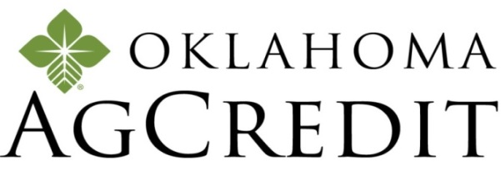
601 E Kenosha, Broken Arrow, OK 74012
Office 918-251-8596 | Cell 918-290-9789
OKAGCREDIT.COM
OK AgCredit has generously donated a Perla Bed
The Marchioro Perla Bases are made with durable plastic that dips down in the front for easy access. Features slits for ventilation; Slits also keep dirt or water from building up; Non-skid feet for inside use; Roomy and cozy for pets to snuggle up; Suitable for indoor or outdoor use

https://www.springtimeinc.com/

Springtime has donated
Fresh Factors 180ct and Joint Health Chewables 180ct
These supplements have helped my older dogs stay active!

CONCESSIONS
Saturday and Sunday Catered Lunch by:
TBA

Accommodations
Hotels and Motels that will accept dogs

Please act responsibly! Keep your pets in crates at motels. Do not bathe or groom dogs in motel rooms. Use heavy plastic under crates. Motels reserve the right to change their pet policy at any time
La Quinta Inn ……. (915) 242-6991 (No limit on number of dogs)
451 W Albany St , Broken Arrow, OK 74012
Clarion Hotel….……………………………………… (918) 258-7085
2600 N. Aspen, Broken Arrow, OK, US, 74012
Homewood Suites (918)-392-7700 4900 W Madison Place, Broken Arrow, OK 74012 (Garnett & 71st)
Aloft Tulsa (918) 949-9000, 6717 S 104th E Ave., Tulsa OK 74133 (no deposit if you sign waiver).

Staybridge Suites (800) 225-1237, 1111 E 73rd St S., Tulsa, OK 74133 ($75 pet fee)

Candlewood Suites (918) 294-9000, 1008 E 74rd St S., Tulsa, OK 74133 (mention “Ilee” for a reduced pet fee of $25)

Days Inn (918) 665-6800, 8201 E Skelly Dr., Tulsa, OK

Motel 6 South (918) 254-1626, 12525 E 52nd St So., Tulsa, OK

Motel 6, (918) 663-4541, 8181 E Skelly Drive, Tulsa OK 74129

Motel 6 West, (918) 445-0223, 5828 W Skelly Dr., Tulsa OK

Directions to Trial Site
27560 E. 77th Street S., Broken, Arrow, OK 74014.

Coming from Tulsa:
Keep straight onto OK-51East/Broken Arrow Expressway 5.4 mi.
Take ramp right and follow signs for Kenosha St. 0.3 mi.
Turn left onto E 71st St S/E Kenosha St, 5.6 mi.
Turn right onto S 273rd East Ave, 0.6 mi.
Turn left onto E 77th St/E 77th S, 0.2 mi.

Coming from Muskogee:
Keep straight onto US-69/N 32nd St, 5.3 mi.
Take ramp left for Muskogee Tpke West, 23.7 mi.
Take ramp right for Creek Tpke toward Creek Tpke E, 1.4 mi.
At exit 25, take ramp right and follow signs for Kenosha St, 0.3 mi.
Turn left onto E 71st St S/E Kenosha St, 3.6 mi.
Turn right onto S 273rd East Ave, 0.6 mi.
Turn left onto E 77th St/E 77th, 0.2 mi.

Coming from Oklahoma City:
Take I-44 East (toll road)
Take Creek Turnpike East exist, EXIT 218, toward Jenks/Broken Arrow
Take the Kenosha St. exit, EXIT 25
Turn left onto E 71st St S/E Kenosha St.
Turn right onto S 273rd East Ave
Turn left onto E 77th St/E 77th St S.

TRACKING NUMBER POLICY

All dogs participating in AHBA events must have full information, including a registration number, provided for entry on recording forms. The registration number to be used should be the dog's regular registration number. In the case of dogs which have more than one registration number, the owner must choose one and use it consistently for AHBA purposes. Owners of unregistered dogs may apply to the AHBA for a tracking number to be used in place of a registration number. The tracking number is only for dogs which are not otherwise registered. The Request for Tracking Number form may be obtained from the AHBA Secretary, email: pacifica19@gmail.com, or regular mail: 1548 Victoria Way, Pacifica, CA 94044. The completed form is sent to the Secretary at the email or mailing address on the form, and the owner will be sent a tracking number to use for entering AHBA events. In addition to using a consistent registration or tracking number, owners must use one consistent name when entering a dog. After June 1, 2010, any incomplete recording form received by the AHBA will not be processed.
TRACKING FORMS WILL BE AVAILABLE ON SITE DAY OF EVENT
DIAGRAMS OF THE HRD COURSE BELOW:
THE DIAGRAM OF THE COURSE IS IN TWO PARTS
PASTURE AREA AND ARENA AREA
FOR SIMPLICITY

Please scroll down

PASTURE AREA

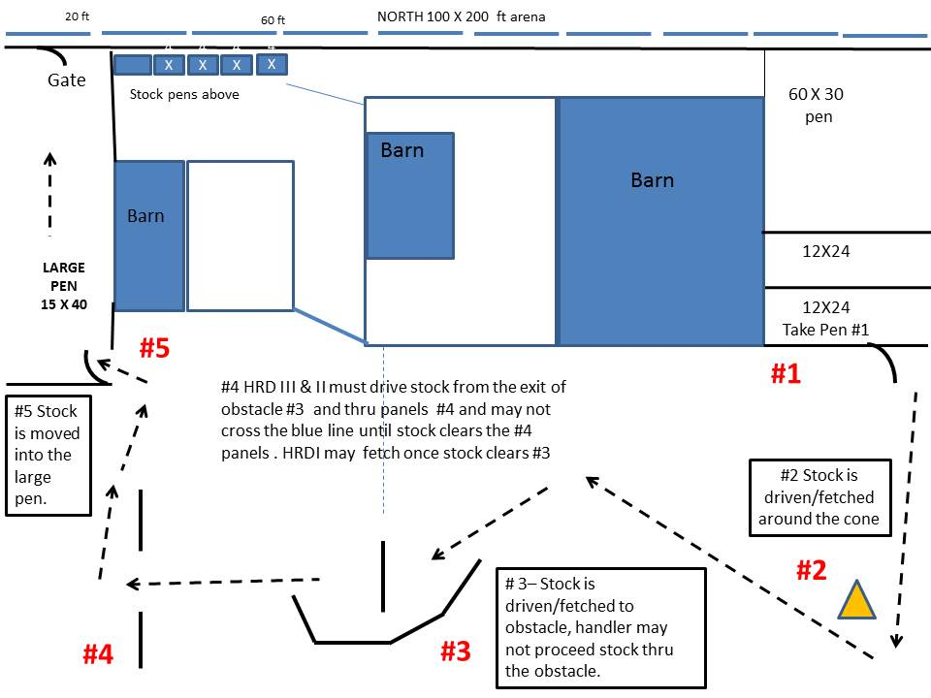

Please scroll down

TRIAL ARENA AREA

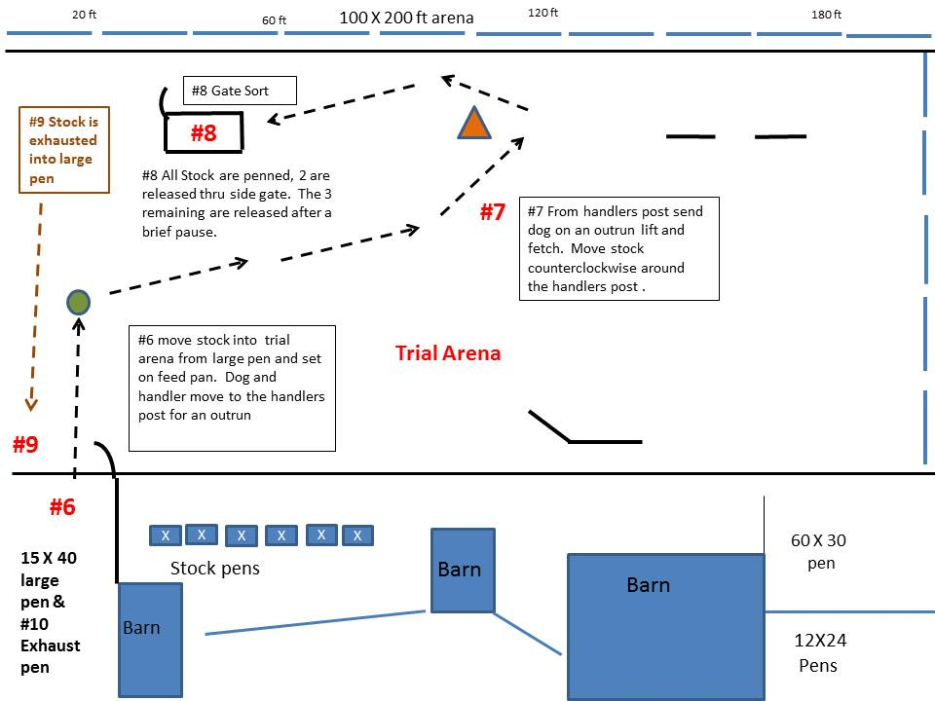

Please scroll down

For Course Description

Herding Ranch Dog HRD I, II, III for Latigo Farm November 17 & 18, 2018
Course Description: 5 hair sheep
Throughout the course, the emphasis should be on smooth, calm, practical work. The sheep should move steadily and quietly, without rushing, lagging or weaving. Except as otherwise specified on certain parts of the course, the dog and handler may take various positions relative to the sheep throughout the course. The time limit for the course is 25 minutes all levels. Ties within classes will be broken on: 1st, highest score on the gate sort; 2nd, highest score on Obstacle #2 in the pasture; 3rd, time.

Take Pen (#1): 5 head of sheep are to be taken out of pen #1, The work is judged on calmness and smoothness. The stock should not rush or crowd the gate. The dog may be placed wherever necessary to accomplish the take pen in the most efficient manner.

Cone (#2): Stock is driven/ fetched to and around the cone clockwise HRD III handlers must drive stock from the take pen and around the cone, HRD III handler may move as soon as stock clears the cone.

Obstacle (#3): Stock is driven/fetched to obstacle #3, the handler may not proceed stock thru the obstacle. Stock should enter from the North end

Free Standing Panels (#4): #4 HRD III & II must drive stock from the exit of obstacle #3 and thru panels #4 and may not cross the blue line that is parallel from the panel pictured in diagram, until stock clears the #4 panels . HRDI may fetch once stock clears #3, but may not proceed the stock thru the free standing panels.

Move stock into Large Pen (#5): Stock is moved into the large pen as quietly and efficiently as possible.

Move stock into trial arena & set stock (#6): move stock into trial arena from large pen and set on feed pan. Dog and handler move to the handlers post for an outrun

Outrun: (#7): From handlers post send dog on an outrun lift and fetch. Move stock counterclockwise around the handlers post . HRD l may fetch to the post following the lift. HRD III handlers must remain at their post till stock pass the post. HRD II handlers may move no more than halfway from the handlers post. HRD I may position the dog halfway between the handlers post and the stock. HRD I handler may move from within 15ft of the stock before sending the dog. Judging for #7 is completed when the stock complete the turn around the handlers post.

Free standing pen & Gate Sort (#8): All Stock are penned using the gate on the North side, 2 are released thru side gate on the west side. The 3 remaining are released after a brief pause. The remaining may be released thru the side gate or the gate on the north side. The work is judged on calmness and smoothness. The stock should not rush or crowd the gate. The dog may be placed wherever necessary to accomplish the sort in the most efficient manner.

Exhaust Pen: (#9) –Upon releasing all the stock from the free standing pen the stock is moved to the Exhaust pen. The stock are fetch/driven to the Exhaust Pen. The dog should hold the stock off the gate to permit the handler to open it safely. The stock is exhausted into the pen in a calm manner. The handler must close the gate. The dog is not to enter the pen area.

The run is ended when the gate is closed.
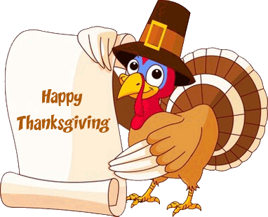

NOTES:

