AMERICAN HERDING BREED ASSOCIATION TRIALS
Sponsored by Melinda Stevenson (Latigo Farm)
TWO TRIALS/TWO DAYS

FALL TURKEY DAYS TRIAL

SATURDAY, NOVEMBER 18, 2017
SUNDAY, NOVEMBER 19, 2017

HERDING RANCH DOG (HRD I, II, III), SHEEP - Course map and description enclosed
HERDING TRIAL ARENA DOG (HTAD I, II, III) SHEEP Course #3 with Gather/Ribbon Pull
HERDING TRIAL ARENA DOG (HTAD I, II, III) DUCKS Course #3 with Gather/Shed
HERDING TRIAL DOG (HTD I, II, III) DUCKS
JUNIOR HERDING DOG (JHD) DUCKS ONLY
TURKEY BUDDY BRACE FUN RUN - Details at the trial, no AHBA points for the fun run

LOCATION: 27560 EAST 77THS ST S., BROKEN ARROW, OK 74014
SATURDAY JUDGE: Rachel Vest (Jefferson, GA)
SUNDAY JUDGE: Lori Herbel (Putnam, OK)

Pre Entry $40/Day of entry $45

Combined sheep runs limited to maximum 30 runs/day
Combined duck runs limited to maximum 25 runs/day
Trials Limited to a Total of 50 Runs/Day

Pre Entries close November 8th, 2017
THERE MUST BE A SEPARATE ENTRY FORM FOR EACH DOG, AND EACH TRIAL LEVEL ENTERED, Entry form is in this premium or you can find one on the AHBA website, http://www.ahba-herding.org/
Pre Entries close November 8th, 2017, must be received by midnight
Day of entries accepted day of the event (thirty minutes prior to the class beginning)

HANDLER’S MEETING AT 8:00 A.M
JUDGING SCHEDULED TO BEGIN AT 8:15 A.M.

Event Hours: 8:00 am to 6:00 pm, or one hour after the conclusion of this event
Event will be held outside regardless of weather

Permission has been granted by the American Herding Breeds Association (AHBA)
to hold the Trial under the AHBA Rules and Regulations.
Open to all Dogs of the Herding Breeds and Multi-Purpose Breeds with Herding Background, as listed in the AHBA Breeds List (Dogs must be 9 months or older for trial)

Mail entries to the Event Secretary:
Melinda Stevenson, 27560 East 77th St S, Broken Arrow, OK 74014
Cell Phone: (918) 557-2349 or E-mail: mshorse@windstream.net
More info and the Premium is also available on www.latigofarm.net

OFFICIAL AHBA ENTRY FORM
AHBA SANCTIONED HERDING TEST AND TRIAL
NAME OF CLUB or PERSON(S) Sponsoring this Event: Melinda Stevenson, Property owner at 27560 East 77th St. S., Broken Arrow OK 74014
Date of Event: November 18th and 19th, 2017
Pre Entries Close On: November 8, 2017
Pre entries must be received no later than Nov 8th at midnight.
Day of entries accepted till trial fills; Day of entry closes thirty minutes prior to class

Make checks or money orders payable in US funds to: Melinda Stevenson
Send to the Trial Secretary :
Melinda Stevenson
27560 East 77th St S., Broken Arrow, OK 74014
ELIGIBILITY
All dogs nine months of age or older are eligible to participate in Herding Trials and JHD. Dogs classified as Herding Dogs in AHBA are eligible for HERDING TEST (HCT) and may participate at six months of age or older. No dog may be entered in two classes on the same course with the same kind of stock under the same judge at any Test/Trial. Bitches in season shall run in drawn running order without adjustment.
IMPORTANT. READ THIS BEFORE SIGNING
RELEASE FORM
In consideration for participation in the Herding Test/Trial held by Melinda Stevenson, I (we) agree to assume all responsibility for any claim, loss or damage, of whatever kind or nature, whether to person or property, which may be caused at or near the Herding Test/Trial, either directly or indirectly, by me or the dog or dogs I (we) have entered or brought to this Herding Test/Trial. I (we) further agree that I (we) will hold Melinda Stevenson, AHBA, its Officers, Directors, Agents and Members; harmless and defend them from any and all liability for any injury, claim, damage or loss, of whatever kind, directly or indirectly, by me (us) or any dog I (we) have entered or brought to this Herding Test/Trial. I (we) agree to indemnify Melinda Stevenson, the AHBA, its Officers, Directors, Agents and Members; for any loss, cost, or expenses, including attorney fees and costs, in which Melinda Stevenson,the AHBA, its Officers, Directors, Agents and Members; might be subject to as a result of any claim, suit, loss or damage caused in any way by any act or negligence on my (our) part or on the part of any dog of dogs I (we) have entered or brought to the Herding Test/Trial. I(we) acknowledge that while Melinda Stevenson may provide for this Herding Test/Trial, it does not have and does not exercise control over the conduct of those present. I (we) certify and represent that the dog or dogs I (we) have entered or brought to this Herding Test/Trial is (are) not a hazard to other dogs, other animals, or to people. I (we) will pay for injuries or replacement value in the event of the death of any livestock by my (our) dog. If injury to any stock is caused by my (our) dog entered or brought to this Herding Test/Trial, I (we) assume full responsibility for any damage. I(we) agree to pay full market value of the injured animal in case of injury or the veterinary bill for the injury, whichever is agreed to by the Livestock Owner. I CERTIFY that I am the actual owner of the dog or that I am the duly authorized agent of the actual owners whose name I have entered.
In consideration of the acceptance of this entry, I (we) agree to abide by the Rules and Regulations of the AHBA in effect at the time of this Herding Test or Trial or both, and further agree to be bound by the agreement printed above. The entry is submitted on the foregoing representation and agreement.
Signature of Owner &/or Agent: ______________________________________________________________________________
Saturday, November 18, 2017
Sunday, November 19, 2017

Herding Ranch Dog (HRD) I, II, III – Sheep- Pre Entry $40/Day of entry $45
Herding Trial Arena Dog (HTAD) I, II, III- Sheep - Pre Entry $40/Day of entry $45
Herding Trial Arena Dog (HTAD) I, II, III - Ducks- Pre Entry $40/Day of entry $45
Herding Trial Dog (HTD) I, II, III - Ducks- Pre Entry $40/Day of entry $45
Junior Herding Dog (JHD) I, II, III - Ducks- Pre Entry $40/Day of entry $45

Entry form must be returned with the release form signed. Any entries received without the signed release will not be accepted.
NOTE: A dog must be entered in the name of the person(s) who actually owns it at the time entries are made for the Herding Test or Trial. A Registration or Tracking Number must be included. Tracking enrollment forms are available on location and will be included with trial results for those folks not yet registered with AHBA, your recorded scores may be delayed until a number is issued by AHBA.
Please circle appropriate class(s)
TRIALS | HRDs | I | II | III $40/$45
TRIALS | HTADs | I | II | III $40/$45
TRIALS | HTADd | I | II | III $40/$45
TRIALS | HTDd | I | II | III $40/$45
TEST | JHD | I | II | $40/$45

ONE FORM PER DAY PER DOG
Actual Owner(s):_________________________________________
Address:________________________
City: ___________________________
State: _____________________
Zip: ____________
Country: USA
Telephone: _________________
Email: ________________________
Agent’s Name (if applicable): ___________________________________
Telephone (Agent only): ______________________
Email (Agent only): __________________________

Full Name of Dog: ____________________________________________
Registration OR Tracking Number: _______________________________
Registry: ______________________
Date of Birth: __________
Place of Birth { } USA { } CANADA { } Other
Breed: _____________________
Variety:_________________________
Sex: _____________
Breeder: ___________________________________________________
Sire: ______________________________________________________
Dam: ______________________________________________________
TWO LEGS ARE REQUIRED TO TITLE IN AHBA AND THERE ARE NO PREREQUISITES –YOU MAY START AT ANY LEVEL

LIVESTOCK
Herding Ranch Dog – Katahdin/Dorper/St Croix Hair Sheep 5-7 head
Herding Trial Arena Dog – Katahdin/Dorper/St Croix Hair Sheep – 4-5 head of stock
Herding Trial Arena Dog –Cross Bred Ducks - 5 head of stock
Herding Trial Dog – Cross Bred Ducks - 3 head of stock
Junior Herding Dog – Cross Bred Ducks - 5 head of stock
Stock replacement values per head: $150 Sheep, $25 Ducks

RIBBON PRIZE FOR EACH DAY
Qualifying Score ………………………………………Dark Green
HRD I, I, III……………………………………………Placement Ribbons 1st thru 4th Place
HTAD I, I, III……………………………………….…Placement Ribbons 1st thru 4th Place
HIGH IN TRIAL for Herding Ranch Dog …………….Rosette
HIGH IN TRIAL for Herding Trial Arena Dog ………….Rosette
HIGH IN TRIAL for Herding Trial Dog ………….Rosette
COMBINED HIGH IN TRIAL
(for highest scoring dog competing in both HRD & HTAD/HTD) …Rosette
OVERALL COMBINED HIGH IN TRIAL ( over both days) …… Rosette

PRIZES & AWARDS
First Place in all trial classes will receive a fun herding themed award
Qualifiers in Junior Herding Dog will receive a fun herding themed award

High In Trial Herding Ranch Dog receives a herding themed award (each day)
High In Trial Herding Trial Arena Dog receives a herding themed award (each day)
(each day) NOTE: HIT for HTAD can be won on either sheep or ducks
High In Trial Herding Trial Dog receives a herding themed award (each day)

COMBINED HIGH IN TRIAL (highest scoring dog competing in both HRD & HTAD/HTD receives herding themed award (each day)
Tie Breaker for above awards will be Outrun, lift and fetch score – 2nd Tie Breaker Time

OVERALL HIGHEST TOTAL COMBINED SCORES FOR BOTH DAYS IN HRD & HTAD/HTD WILL RECEIVE A HAND TOOLED 3 CORNER LEATHER CHAIR DESIGNED BY COUNTRY IMAGES
Must Q in both HRD and HTAD/HTD

Medallions for First Time Exhibitors
Medallions for New Titles
Giveaway Raffle Baskets including No “Q” and workers raffle!

Additional prizes and awards courtesy of

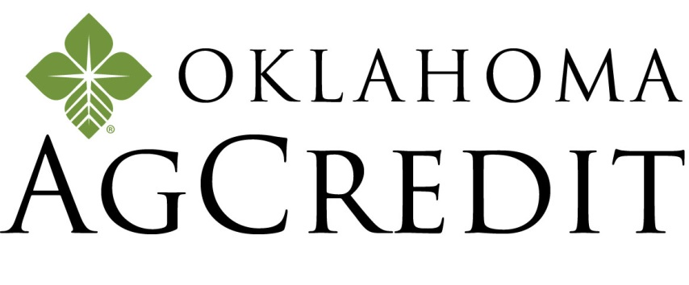
Oklahoma AgCredit
601 E Kenosha
Broken Arrow, OK 74012
Office 918-251-8596 | Cell 918-290-9789
OKAGCREDIT.COM

CONCESSIONS
Saturday and Sunday Catered Lunch by:
TBA

Accommodations
Hotels and Motels that will accept dogs:

TownePlace Suites Tulsa Broken Arrow
2251 W Stone Wood Dr…………… (918) 355-9600
Just off Highway 51/ Elm exit, dine at LOS CABOS, LONESTAR STEAKHOUSE, CHARLESTONS, & OKLAHOMA JOE'S BBQ, find the outdoorsman in you at BASS PRO SHOPS located adjacent to the hotel . I am working on a room discount!

Clarion Hotel….………………………………………..…………(918) 258-7085
2600 N. Aspen , Broken Arrow, OK, US, 74012, Phone: (918) 258-7085 Fax: (918) 251-6768 http://www.clarionoftulsa.com Email: gm.ok161@choicehotels.com
Located on the Aspen exit (145th East Ave.) off the BA Expressway (Hwy. 51), on the southwest corner of the BA Expressway and Aspen Ave. Mention you are at the dog event at Latigo Farm for a discount of rate per night.

Directions to Trial Site
27560 E. 77th Street S., Broken, Arrow, OK 74014.

Coming from Tulsa:
Keep straight onto OK-51East/Broken Arrow Expressway 5.4 mi.
Take ramp right and follow signs for Kenosha St. 0.3 mi.
Turn left onto E 71st St S/E Kenosha St, 5.6 mi.
Turn right onto S 273rd East Ave, 0.6 mi.
Turn left onto E 77th St/E 77th S, 0.2 mi.

Coming from Muskogee:
Keep straight onto US-69/N 32nd St, 5.3 mi.
Take ramp left for Muskogee Tpke West, 23.7 mi.
Take ramp right for Creek Tpke toward Creek Tpke E, 1.4 mi.
At exit 25, take ramp right and follow signs for Kenosha St, 0.3 mi.
Turn left onto E 71st St S/E Kenosha St, 3.6 mi.
Turn right onto S 273rd East Ave, 0.6 mi.
Turn left onto E 77th St/E 77th, 0.2 mi.

Coming from Oklahoma City:
Take I-44 East (toll road)
Take Creek Turnpike East exist, EXIT 218, toward Jenks/Broken Arrow
Take the Kenosha St. exit, EXIT 25
Turn left onto E 71st St S/E Kenosha St.
Turn right onto S 273rd East Ave
Turn left onto E 77th St/E 77th St S.

TRACKING NUMBER POLICY

All dogs participating in AHBA events must have full information, including a registration number, provided for entry on recording forms. The registration number to be used should be the dog's regular registration number. In the case of dogs which have more than one registration number, the owner must choose one and use it consistently for AHBA purposes. Owners of unregistered dogs may apply to the AHBA for a tracking number to be used in place of a registration number. The tracking number is only for dogs which are not otherwise registered. The Request for Tracking Number form may be obtained from the AHBA Secretary, email: pacifica19@gmail.com, or regular mail: 1548 Victoria Way, Pacifica, CA 94044. The completed form is sent to the Secretary at the email or mailing address on the form, and the owner will be sent a tracking number to use for entering AHBA events. In addition to using a consistent registration or tracking number, owners must use one consistent name when entering a dog. After June 1, 2010, any incomplete recording form received by the AHBA will not be processed.
TRACKING FORMS WILL BE AVAILABLE ON SITE DAY OF EVENT
DIAGRAMS OF THE HRD COURSE BELOW:
THE DIAGRAM OF THE COURSE IS IN TWO PARTS
PASTURE AREA AND ARENA AREA
FOR SIMPLICITY

Please scroll down

PASTURE AREA

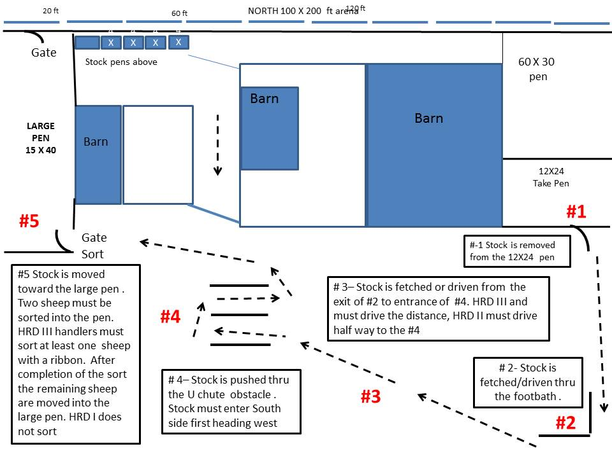

Please scroll down

TRIAL ARENA AREA

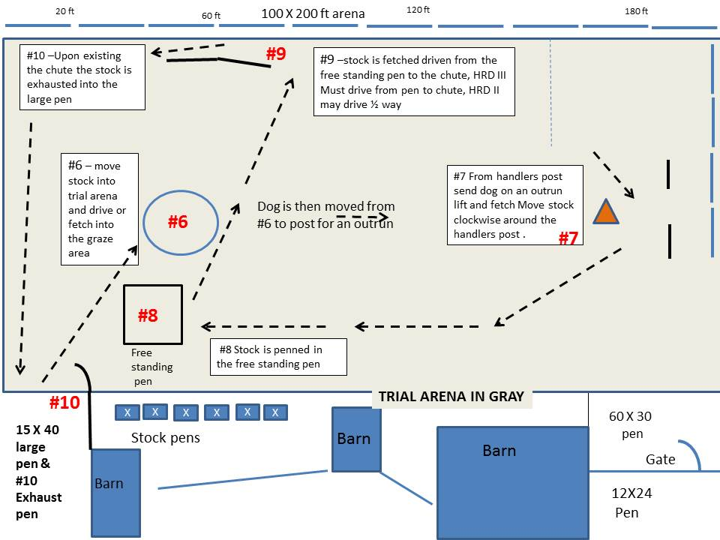

Please scroll down

For Course Description

Herding Ranch Dog HRD I, II, III for Latigo Farm November 18th & 19th, 2017
Course Description: 5 -7 hair sheep
Throughout the course, the emphasis should be on smooth, calm, practical work. The sheep should move steadily and quietly, without rushing, lagging or weaving. Except as otherwise specified on certain parts of the course, the dog and handler may take various positions relative to the sheep throughout the course. The time limit for the course is 25 minutes for HRD I and II, 30 minutes HRD III. Ties within classes will be broken on: 1st, highest score on the gate sort; 2nd, highest score on u chute; 3rd, time.

Take Pen/Exit from Pen (#1): The stock are taken from the pen, approximately 12X24 ft. in size (#1) under the direction of the handler. The work is judged on calmness and smoothness. The stock should not rush or crowd the gate. The dog may be placed wherever necessary to accomplish the exit from the pen in the most efficient manner. After all the stock have left the pen, the dog holds them while the handler closes the gate. If when the gate is opened the stock want to come out on their own, this is acceptable, so long as the dog immediately establishes control.
HRD I -- the handler may enter the pen if desired, and move around as needed to assist the dog, but may not touch the dog or stock. The dog may be brought into the pen on lead if desired, but there must be a definite pause after the leash is removed, before the dog is sent to collect the sheep.
HRD II -- the handler may enter the pen if desired, but must stand just inside the gate while the dog collects the stock. The dog must enter the pen off-lead.
HRD III -- handlers may not enter the pen

Footbath: (#2)-Stock is driven/fetched thru footbath.
HRD lll and HRD ll handlers may NOT precede the stock passing thru the footbath.
HRD I -- can fetch or drive the stock through the footbath.

Drive/Fetch to the U Chute: (#3) - HRD lll handlers must remain at the footbath and the dog must drive the stock to the U chute, the handler may move once at least one head of stock has entered the chute.
HRD II handlers must drive halfway to the U Chute before preceding to the U Chute.
HRD I -- can fetch or drive the stock to the U Chute

U Chute Panels: (#4) Stock is driven/fetched thru the U chute. Stock should enter on the south side heading west as indicated by the arrow, make a U turn and go thru the other side of the panels heading east . Points will be deducted for any stock entering the opposite sides.
Handlers may not enter the panels, however they can move anywhere along the outside of the panels .

Gate/ Sort (#5) – Stock is moved toward the 15X40 large pen . HRD III and HRD II handlers must sort two sheep into the large pen. HRD III handlers must sort at least one sheep with a ribbon. HRD I does not sort, instead all stock are penned into the large pen. After completion of the gate/sort the remaining sheep are moved into the large pen for HRD III and HRD II. Handlers may take a 2 minute water break inside the large pen.

Trial Arena (#6) – The Stock is moved from the large pen into the trial arena, the gate is closed behind the stock. The stock is then driven or fetched to the graze area.
Stock must be moved as quietly and safely as possible into the trial arena.

Outrun: (#7)- The handler and dog proceed to the handlers post leaving the stock in the grazing area. From the designated handlers post send the dog on an outrun, lift and fetch to pick up stock, drive stock around the handlers post in a clockwise direction. HRD l may fetch to the post following the lift. HRD III handlers must remain at their post till stock pass the post. HRD II handlers may move no more than halfway from the handlers post. HRD I may position the dog halfway between the handlers post and the stock. HRD I handler may move from within 15ft of the stock before sending the dog. Judging for #7 is completed when the stock complete the turn around the handlers post.

Free Standing Pen (#8) The stock is driven or fetched from the handlers post to the free standing pen. All the stock must be penned for HRD III and HRD II. Deductions will be taken for stock not penned for HRD I. Scoring for the pen ends when the pen gate is closed.

Y Chute Panels: (#9 ) - Stock is fetched driven from the free standing pen to the Y chute, HRD III must drive from the pen to the opening of the Y chute, HRD II must drive ½ way, HRD I may drive or fetch

Exhaust Pen: (#10) –Upon existing the Y chute the stock is moved to the Exhaust pen. The stock are fetch/driven to the Exhaust Pen. The dog should hold the stock off the gate to permit the handler to open it safely. The stock are exhausted into the pen in a calm manner. The handler must close the gate. The dog is not to enter the pen area.

The run is ended when the gate is closed.

______________________________________________________________________________

TURKEY DAYS BUDDY BRACE FUN MATCH:
IF TIME ALLOWS WE WILL RUN A FUN MATCH FOLLOWING THE LAST CLASS ON SATURDAY NOVEMBER 18TH 2017

HTD COURSE
STOCK: MIXED POULTRY WITH TURKEY AND DUCKS
TWO DOGS AND TWO HANDLERS
$5 ENTRY FEE PER DOG
ENTER AS MANY TIMES AS YOU WISH WITH DIFFERNET PARTNERS
ENTER DAY OF TRIAL

