AMERICAN HERDING BREED ASSOCIATION TRIALS
Sponsored by Melinda Stevenson (Latigo Farm)
TWO TRIALS/TWO DAYS

THIRD ANNUAL BELT BUCKLE CHALLNEGE

SATURDAY, JUNE 3rd, 2017
SUNDAY, JUNE 4TH, 2017

HERDING RANCH DOG (HRD I, II, III), SHEEP - Course map and description enclosed
HERDING TRIAL ARENA DOG (HTAD I, II, III) SHEEP Course #4 with Gather/Shed
HERDING TRIAL ARENA DOG (HTAD I, II, III) DUCKS Course #4 with Gather/Shed
HERDING TRIAL DOG (HTD I, II, III) DUCKS
JUNIOR HERDING DOG (JHD) DUCKS ONLY

LOCATION: 27560 EAST 77THS ST S., BROKEN ARROW, OK 74014
SATURDAY JUDGE: Roberta McKowen (Jackson, LA)
SUNDAY JUDGE: Ken Theus (Boerne, TX)

Pre Entry $40/Day of entry $45

Combined sheep runs limited to maximum 30 runs/day
Combined duck runs limited to maximum 25 runs/day
Trials Limited to a Total of 50 Runs/Day

Pre Entries close May 24th, 2017
THERE MUST BE A SEPARATE ENTRY FORM FOR EACH DOG, AND EACH TRIAL LEVEL ENTERED, Entry form is in this premium or you can find one on the AHBA website, http://www.ahba-herding.org/
Pre Entries close May 24, 2017, must be received by midnight
Day of entries accepted day of the event (thirty minutes prior to the class beginning)

HANDLER’S MEETING AT 8:00 A.M
JUDGING SCHEDULED TO BEGIN AT 8:15 A.M.

Event Hours: 8:00 am to 6:00 pm, or one hour after the conclusion of this event
Event will be held outside regardless of weather

Permission has been granted by the American Herding Breeds Association (AHBA)
to hold the Trial under the AHBA Rules and Regulations.
Open to all Dogs of the Herding Breeds and Multi-Purpose Breeds with Herding Background, as listed in the AHBA Breeds List (Dogs must be 9 months or older for trial)

Mail entries to the Event Secretary:
JoyceAnn Baker, 20965 E 36th Pl, S, Broken Arrow, OK 74014
Phone: (918) 504-2229 or E-mail: jbaker40@cox.net
Contact Info: Melinda Stevenson
Cell phone; 918-557-2349 Email; mshorse@valornet.com
More info and the Premium is also available on www.latigofarm.net
OFFICIAL AHBA ENTRY FORM
AHBA SANCTIONED HERDING TEST AND TRIAL
NAME OF CLUB or PERSON(S) Sponsoring this Event: Melinda Stevenson, Property owner at 27560 East 77th St. S., Broken Arrow OK 74014
Date of Event: June 3 and 4th, 2017
Pre Entries Close On: May 24th, 2017
Pre entries must be received no later than May 24th at midnight.
Day of entries accepted till trial fills; Day of entry closes thirty minutes prior to class

Make checks or money orders payable in US funds to: Melinda Stevenson
Send to the Trial Secretary :
JoyceAnn Baker
20965 E 36th Pl. S., Broken Arrow, OK 74014
ELIGIBILITY
All dogs nine months of age or older are eligible to participate in Herding Trials and JHD. Dogs classified as Herding Dogs in AHBA are eligible for HERDING TEST (HCT) and may participate at six months of age or older. No dog may be entered in two classes on the same course with the same kind of stock under the same judge at any Test/Trial. Bitches in season shall run in drawn running order without adjustment.
IMPORTANT. READ THIS BEFORE SIGNING
RELEASE FORM
In consideration for participation in the Herding Test/Trial held by Melinda Stevenson, I (we) agree to assume all responsibility for any claim, loss or damage, of whatever kind or nature, whether to person or property, which may be caused at or near the Herding Test/Trial, either directly or indirectly, by me or the dog or dogs I (we) have entered or brought to this Herding Test/Trial. I (we) further agree that I (we) will hold Melinda Stevenson, AHBA, its Officers, Directors, Agents and Members; harmless and defend them from any and all liability for any injury, claim, damage or loss, of whatever kind, directly or indirectly, by me (us) or any dog I (we) have entered or brought to this Herding Test/Trial. I (we) agree to indemnify Melinda Stevenson, the AHBA, its Officers, Directors, Agents and Members; for any loss, cost, or expenses, including attorney fees and costs, in which Melinda Stevenson,the AHBA, its Officers, Directors, Agents and Members; might be subject to as a result of any claim, suit, loss or damage caused in any way by any act or negligence on my (our) part or on the part of any dog of dogs I (we) have entered or brought to the Herding Test/Trial. I(we) acknowledge that while Melinda Stevenson may provide for this Herding Test/Trial, it does not have and does not exercise control over the conduct of those present. I (we) certify and represent that the dog or dogs I (we) have entered or brought to this Herding Test/Trial is (are) not a hazard to other dogs, other animals, or to people. I (we) will pay for injuries or replacement value in the event of the death of any livestock by my (our) dog. If injury to any stock is caused by my (our) dog entered or brought to this Herding Test/Trial, I (we) assume full responsibility for any damage. I(we) agree to pay full market value of the injured animal in case of injury or the veterinary bill for the injury, whichever is agreed to by the Livestock Owner. I CERTIFY that I am the actual owner of the dog or that I am the duly authorized agent of the actual owners whose name I have entered.
In consideration of the acceptance of this entry, I (we) agree to abide by the Rules and Regulations of the AHBA in effect at the time of this Herding Test or Trial or both, and further agree to be bound by the agreement printed above. The entry is submitted on the foregoing representation and agreement.
Signature of Owner &/or Agent: ______________________________________________________________________________
Saturday, June 3, 2017
Sunday, June 4, 2017

Herding Ranch Dog (HRD) I, II, III – Sheep- Pre Entry $40/Day of entry $45
Herding Trial Arena Dog (HTAD) I, II, III- Sheep - Pre Entry $40/Day of entry $45
Herding Trial Arena Dog (HTAD) I, II, III - Ducks- Pre Entry $40/Day of entry $45
Herding Trial Dog (HTD) I, II, III - Ducks- Pre Entry $40/Day of entry $45
Junior Herding Dog (JHD) I, II, III - Ducks- Pre Entry $40/Day of entry $45

Entry form must be returned with the release form signed. Any entries received without the signed release will not be accepted.
NOTE: A dog must be entered in the name of the person(s) who actually owns it at the time entries are made for the Herding Test or Trial. A Registration or Tracking Number must be included. Tracking enrollment forms are available on location and will be included with trial results for those folks not yet registered with AHBA, your recorded scores may be delayed until a number is issued by AHBA.
Please circle appropriate class(s)
TRIALS | HRDs | I | II | III $40/$45
TRIALS | HTADs | I | II | III $40/$45
TRIALS | HTADd | I | II | III $40/$45
TRIALS | HTDd | I | II | III $40/$45
TEST | JHD | I | II | $40/$45

ONE FORM PER DAY PER DOG
Actual Owner(s):_________________________________________
Address:________________________
City: ___________________________
State: _____________________
Zip: ____________
Country: USA
Telephone: _________________
Email: ________________________
Agent’s Name (if applicable): ___________________________________
Telephone (Agent only): ______________________
Email (Agent only): __________________________

Full Name of Dog: ____________________________________________
Registration OR Tracking Number: _______________________________
Registry: ______________________
Date of Birth: __________
Place of Birth { } USA { } CANADA { } Other
Breed: _____________________
Variety:_________________________
Sex: _____________
Breeder: ___________________________________________________
Sire: ______________________________________________________
Dam: ______________________________________________________
TWO LEGS ARE REQUIRED TO TITLE IN AHBA AND THERE ARE NO PREREQUISITES –YOU MAY START AT ANY LEVEL

LIVESTOCK
Herding Ranch Dog – Katahdin/Dorper/St Croix Hair Sheep 5-7 head
Herding Trial Arena Dog – Katahdin/Dorper/St Croix Hair Sheep – 4-5 head of stock
Herding Trial Arena Dog – Rouens & Cross Bred Ducks - 5 head of stock
Herding Trial Dog – Rouen Ducks - 5 head of stock
Junior Herding Dog – Cross Bred Ducks - 5 head of stock
Stock replacement values per head: $150 Sheep, $25 Ducks

RIBBON PRIZE FOR EACH DAY
Qualifying Score ………………………………………Dark Green
HRD I, I, III……………………………………………Placement Ribbons 1st thru 4th Place
HTAD I, I, III……………………………………….…Placement Ribbons 1st thru 4th Place
HIGH IN TRIAL for Herding Ranch Dog …………….Rosette
HIGH IN TRIAL for Herding Trial Arena Dog ………….Rosette
HIGH IN TRIAL for Herding Trial Dog ………….Rosette
COMBINED HIGH IN TRIAL
(for highest scoring dog competing in both HRD & HTAD/HTD) …Rosette

PRIZES & AWARDS
First Place in all trial classes will receive a fun herding themed award
Qualifiers in Junior Herding Dog will receive a fun herding themed award

High In Trial Herding Ranch Dog receives a herding themed award (each day)
High In Trial Herding Trial Arena Dog receives a herding themed award (each day)
(each day) NOTE: HIT for HTAD can be won on either sheep or ducks
High In Trial Herding Trial Dog receives a herding themed award (each day)

COMBINED HIGH IN TRIAL (highest scoring dog competing in both HRD & HTAD/HTD receives a wooden handcrafted engraved leash holder from Country Images (each day)
Tie Breaker for above awards will be Outrun, lift and fetch score – 2nd Tie Breaker Time

3RD ANNUAL BELT BUCKLE CHALLENGE
OVERALL HIGHEST TOTAL COMBINED SCORES FOR BOTH DAYS IN HRD & HTAD/HTD WILL RECEIVE A PERSONALIZED ENGRAVED SILVER BUCKLE
Handcrafted by Molly Custom Silver - http://www.mollyscustomsilver.com/
Must Q in both HRD and HTAD/HTD
2016 Buckle was won by HC WTCH HTCh C-Horse Gee; Joyce Hryekewicz
2015 Buckle was won by Donna Walker & Mirk!

Medallions for First Time Exhibitors
Medallions for New Titles
Giveaway Raffle Baskets including No “Q” and workers raffle!

Additional prizes and awards courtesy of

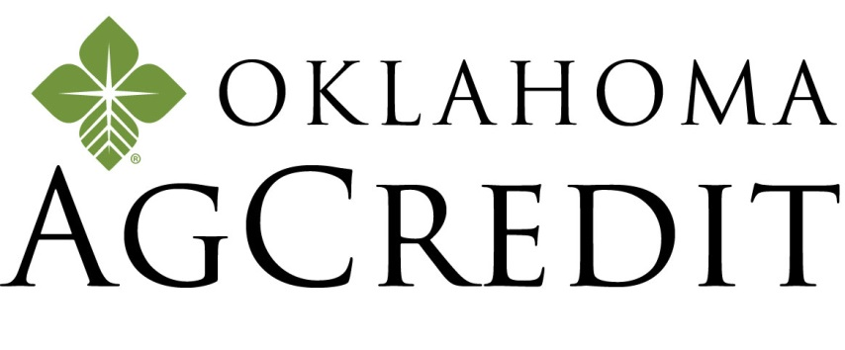
Oklahoma AgCredit
601 E Kenosha
Broken Arrow, OK 74012
Office 918-251-8596 | Cell 918-290-9789
OKAGCREDIT.COM

CONCESSIONS
Saturday and Sunday Catered Lunch by:
TBA

Accommodations
Hotels and Motels that will accept dogs:

TownePlace Suites Tulsa Broken Arrow
2251 W Stone Wood Dr…………… (918) 355-9600
Just off Highway 51/ Elm exit, dine at LOS CABOS, LONESTAR STEAKHOUSE, CHARLESTONS, & OKLAHOMA JOE'S BBQ, find the outdoorsman in you at BASS PRO SHOPS located adjacent to the hotel . I am working on a room discount!

Clarion Hotel….………………………………………..…………(918) 258-7085
2600 N. Aspen , Broken Arrow, OK, US, 74012, Phone: (918) 258-7085 Fax: (918) 251-6768 http://www.clarionoftulsa.com Email: gm.ok161@choicehotels.com
Located on the Aspen exit (145th East Ave.) off the BA Expressway (Hwy. 51), on the southwest corner of the BA Expressway and Aspen Ave. Mention you are at the dog event at Latigo Farm for a discount of rate per night.

Directions to Trial Site
27560 E. 77th Street S., Broken, Arrow, OK 74014.

Coming from Tulsa:
Keep straight onto OK-51East/Broken Arrow Expressway 5.4 mi.
Take ramp right and follow signs for Kenosha St. 0.3 mi.
Turn left onto E 71st St S/E Kenosha St, 5.6 mi.
Turn right onto S 273rd East Ave, 0.6 mi.
Turn left onto E 77th St/E 77th S, 0.2 mi.

Coming from Muskogee:
Keep straight onto US-69/N 32nd St, 5.3 mi.
Take ramp left for Muskogee Tpke West, 23.7 mi.
Take ramp right for Creek Tpke toward Creek Tpke E, 1.4 mi.
At exit 25, take ramp right and follow signs for Kenosha St, 0.3 mi.
Turn left onto E 71st St S/E Kenosha St, 3.6 mi.
Turn right onto S 273rd East Ave, 0.6 mi.
Turn left onto E 77th St/E 77th, 0.2 mi.

Coming from Oklahoma City:
Take I-44 East (toll road)
Take Creek Turnpike East exist, EXIT 218, toward Jenks/Broken Arrow
Take the Kenosha St. exit, EXIT 25
Turn left onto E 71st St S/E Kenosha St.
Turn right onto S 273rd East Ave
Turn left onto E 77th St/E 77th St S.

TRACKING NUMBER POLICY

All dogs participating in AHBA events must have full information, including a registration number, provided for entry on recording forms. The registration number to be used should be the dog's regular registration number. In the case of dogs which have more than one registration number, the owner must choose one and use it consistently for AHBA purposes. Owners of unregistered dogs may apply to the AHBA for a tracking number to be used in place of a registration number. The tracking number is only for dogs which are not otherwise registered. The Request for Tracking Number form may be obtained from the AHBA Secretary, email: pacifica19@gmail.com, or regular mail: 1548 Victoria Way, Pacifica, CA 94044. The completed form is sent to the Secretary at the email or mailing address on the form, and the owner will be sent a tracking number to use for entering AHBA events. In addition to using a consistent registration or tracking number, owners must use one consistent name when entering a dog. After June 1, 2010, any incomplete recording form received by the AHBA will not be processed.
TRACKING FORMS WILL BE AVAILABLE ON SITE DAY OF EVENT
DIAGRAMS OF THE HRD COURSE BELOW:
THE DIAGRAM OF THE COURSE IS IN TWO PARTS
PASTURE AREA AND ARENA AREA
FOR SIMPLICITY

Please scroll down

TRIAL ARENA AREA

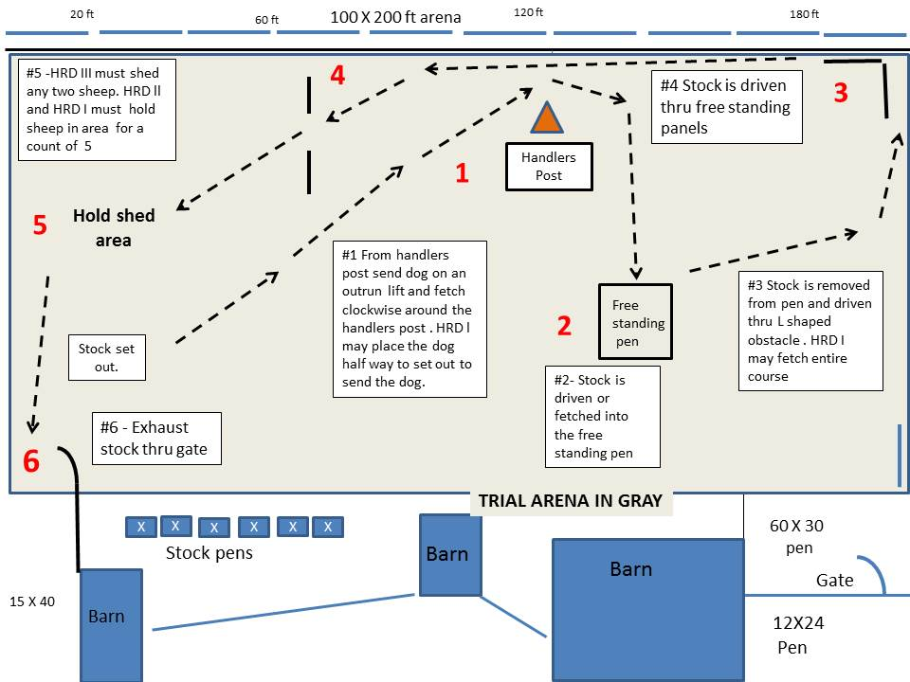

Please scroll down

TRIAL PASTURE AREA

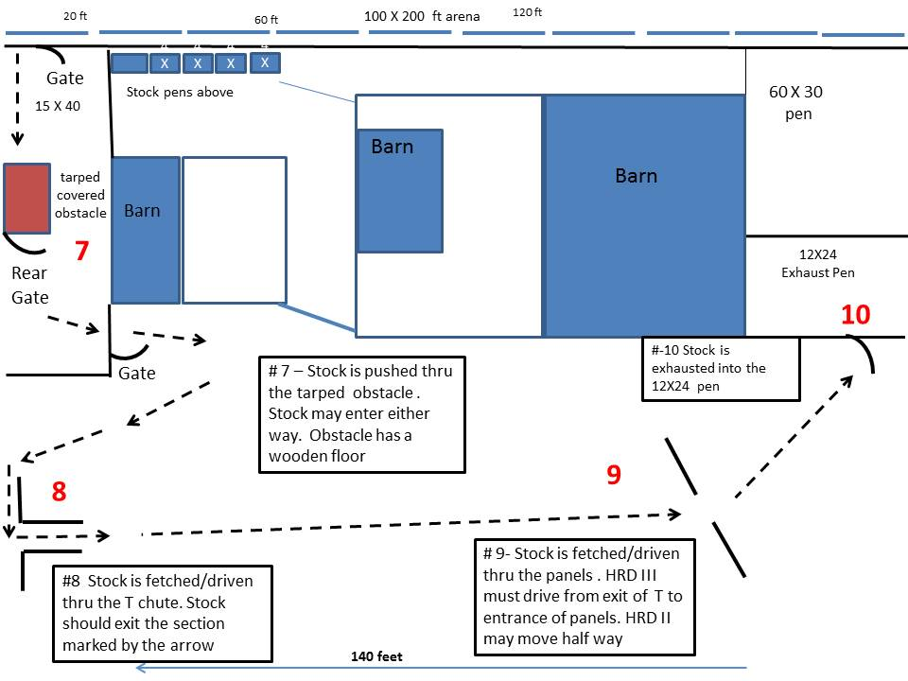

Please scroll down

For Course Description

Herding Ranch Dog HRD I, II, III for Latigo Farm June 3, 4 2017
Course Description: 5 -7 hair sheep
Throughout the course, the emphasis should be on smooth, calm, practical work. The sheep should move steadily and quietly, without rushing, lagging or weaving. Except as otherwise specified on certain parts of the course, the dog and handler may take various positions relative to the sheep throughout the course. The time limit for the course is 25 minutes for HRD I and II, 30 minutes HRD III. Ties within classes will be broken on: 1st, highest score on Shed/hold; 2nd, highest score on T chute; 3rd, time.

Outrun: (#1)- From the designated handlers post send the dog on an outrun, lift and fetch to pick up stock, drive stock around the handlers post in a clockwise direction. HRD III handlers must remain at their post till stock pass the post. HRD II handlers may position themselves no more than halfway from the handlers post to begin the outrun, but the dog must remain at the post. HRD I may position the dog halfway between the handlers post and the stock. HRD I handler may move from within 15ft of the stock before sending the dog. Judging for #1 is completed when the stock complete the turn around the handlers post.

Free Standing Pen : (#2)- Stock is driven or fetched to the free standing pen and penned.
Once the gate is opened all handlers must continue to hold the rope until stock is penned.
Stock is then removed from the pen
HRD I -- the handler may enter the pen if desired, and move around as needed to assist the dog, but may not touch the dog or stock. HRD II -- the handler may enter the pen if desired, but must stand just inside the gate while the dog removes the stock.
HRD III -- handlers may not enter the pen. Judging for #2 is completed when the stock exists the free standing pen

L Shaped Panels: (#3)-Stock is driven/fetched thru the L Panels
HRD III must remain a crooks length from the free standing pen and drive the stock thru the L panels. HRD II & I handlers may drive or fetch to the entrance of the L Panels
Handlers may NOT precede the stock passing thru the panels. Judging for #3 is complete when the stock clears the panels

Center line Panels: (#4)-Stock is driven/fetched thru center line panels.
HRD lll and HRD ll handlers may NOT precede the stock passing thru the panels.
HRD I -- can fetch or drive the stock through the panels and they may walk between the center panels. Judging for #4 is complete when the stock clears the panels

Shed/Hold: (#5) – Stock is taken into the Shed/ Hold area marked with a circle. HRD III must then shed two sheep from the hold/shed area. HRD II and HRD I must hold all the sheep in the hold area for a count of 5. Deductions will be taken for any sheep that will not hold for HRD II and HRD I. Judging for #5 is complete when the shed/hold is completed.

Exhaust thru the Gate (#6) – The stock are fetched or driven to the arena exit gate. The dog should hold the stock off the gate while the handler opens it. The stock is moved into the 15X40 pen. The gate is closed behind the stock. The dog should remain near the handler as the gate is closed and not disturb the stock that has just been driven into the 15X40 pen.
Stock is moved into the trial arena. Stock must be moved as quietly and safely as possible into the trial arena. Dog and handler also enter the trial arena and the handler is to close the gate.
Judging for #6 is complete when the stock exits the pen

Tarped Open Obstacle (# 7 )– The 8X4 ft tarped obstacle has a 4 inch raised wooden floor. Stock is pushed thru the obstacle. Handlers may not enter the tarped area. Stock may enter either direction. After existing the tarped obstacle the stock is exhausted into the pasture thru a gate.
Stock must be moved as quietly and safely as possible into the pasture. Dog and handler also enter the pasture and the handler is to close the gate. Judging for #7 is complete when the stock enters the pasture

T Chute Panels: (#8) Stock is driven/fetched thru the T chute. Stock should exit thru the opening indicated by the arrow ( middle of the T). Points will be deducted for any stock exiting the sides. Judging for #8 is complete when the stock clears the T Chute panels

Center Line Panels (# 9) - Stock is driven/fetched thru the center line panels . HRD III must drive from exit of T to entrance of centerline panels. HRD II may move half way to the centerline panels for the drive. Handlers may NOT precede the stock passing thru the panels. HRD I -- can fetch or drive the stock through the panels. Judging for #9 is complete when the stock clears the panels

Exhaust Re Pen (#10) – The stock are fetched or driven to the 12 X24 pen. The dog should hold the stock off the gate while the handler opens it. The stock is moved into the pen. The gate is closed behind the stock. Judging for #10 is complete when the gate is closed
.

